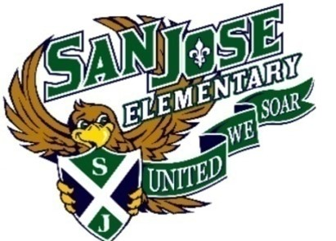

***Supply Request List for Pre-K

1. Backpack
2. 2 sets of extra clothes including shoes
3. Cot sheet & Blanket
4. Pull-ups with re-attachable sides & wet wipes (if not yet potty-trained - REQUIRED)
5. Sanitary Gloves (for pull-up changes)
6. Bleach Wipes
7. 1 box of Tissues
8. 1 box of Crayons
9. 1 box of Washable Markers

Wish List for Pre-K

- Sanitizer
- Disinfectant Spray
- Paper Towels
- Paper Plates
- Dixie cups or coffee filters to serve snack in
- Band-Aids
- Ziploc Bags (all sizes)
- Sharable healthy snacks

***Please let the school know if you are unable to provide the requested supplies and arrangements will be made to provide the necessary supplies.

